SAFETY TIPS FOR USING EXTENSION CORDS

Household Extension Cords Can Cause Fires

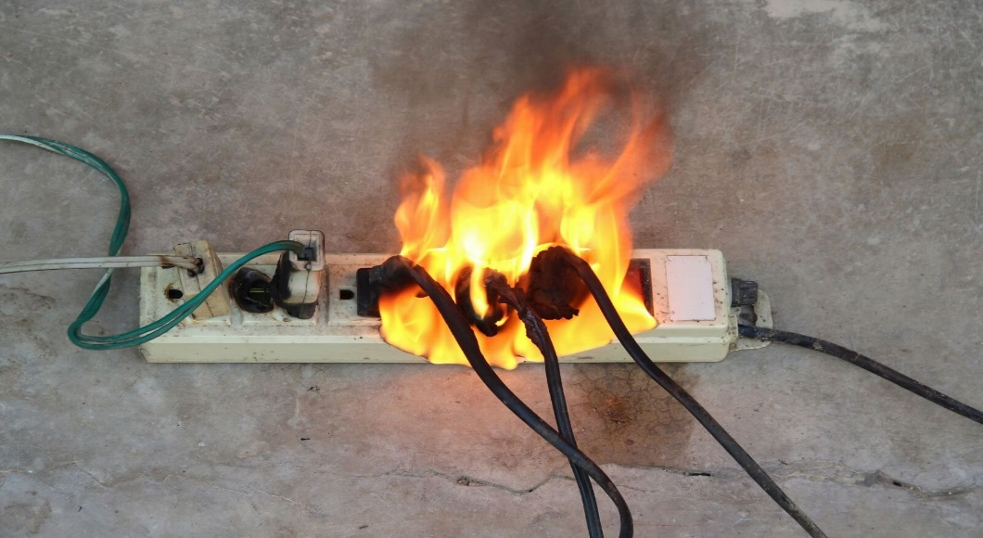
- Always use the right extension cord to connect the home appliances. It can cause fires when used improperly due to overheating. The overheating is usually caused by overloading or using electrical appliances with more power (wattage) than the extension cord can handle.
- Unplug the extension cords when not in use and look for visible signs of excessive wear or damage to the plug, sockets or insulation.
- Replace damaged extension cords.

Handling of Extension of Extension Cords
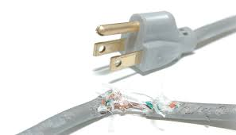
- Do not run extension cords under carpets, through doorways or under furniture.
- Never alter or change its length or perform inadequate repairs such as taping up damaged insulation.
- Never add additional sockets to the cord.

Prevent Overloading of Extension Cords

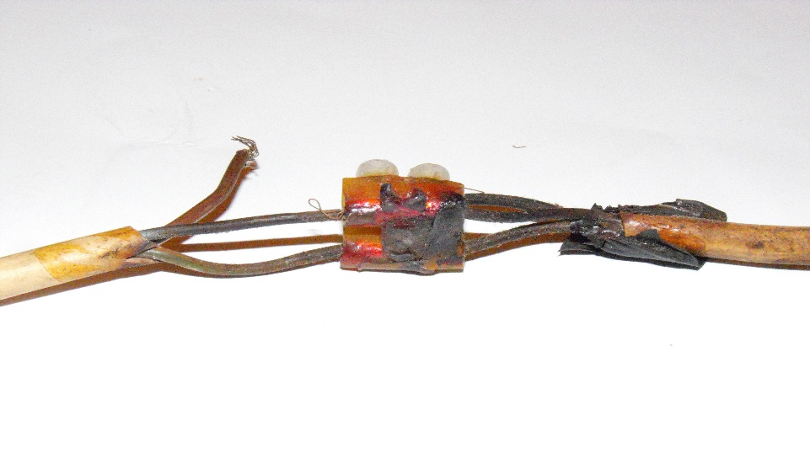
- If any part of the extension cord is hot while in use, it is a warning sign that it may be loosely connected or overloaded. Disconnect the load (appliances) immediately.
- Do not overload the extension cord beyond its capacity. Check its capacity, or rating, by looking at the tag on the cord or its packaging and connect the appliances.

